Import spark session:

Creating rdds:

Using parallelize:

Create dataframes:

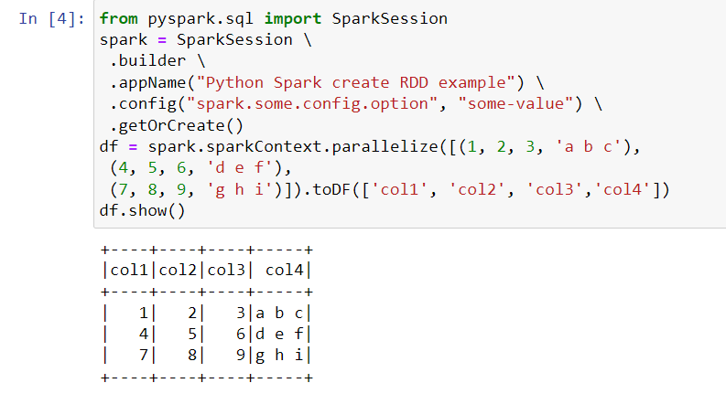

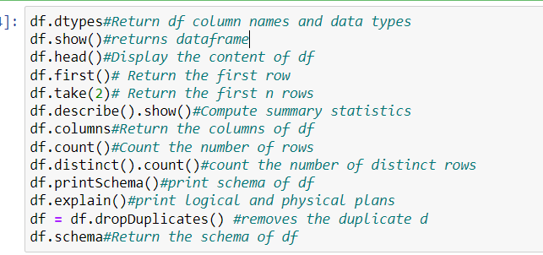

Selecting columns:

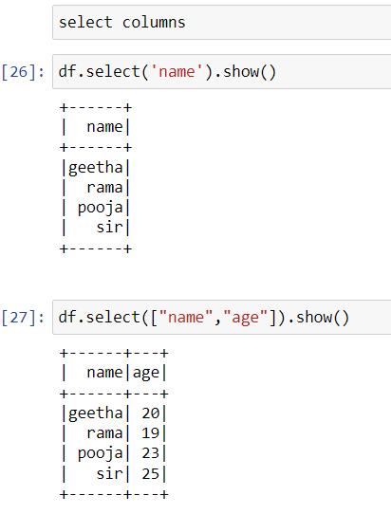

Renaming columns:

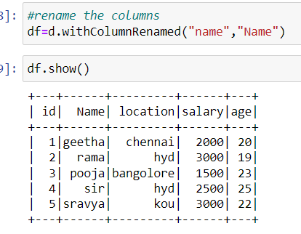

Adding columns:

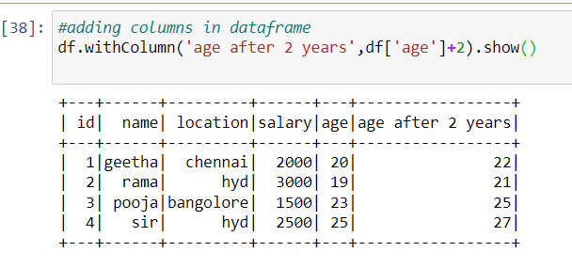

Drop columns:

Sort:

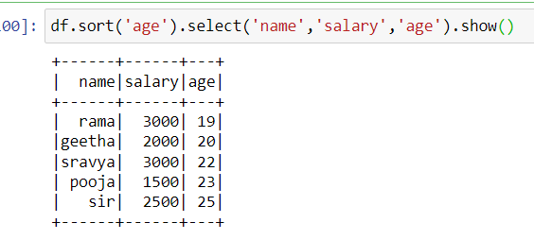

Filter:

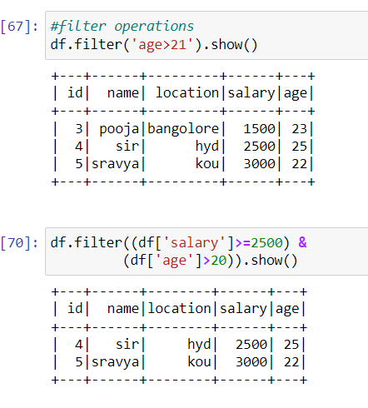

Dropping null values (NA function):

It has 3 parameters:

how=any/all,thresh,subset

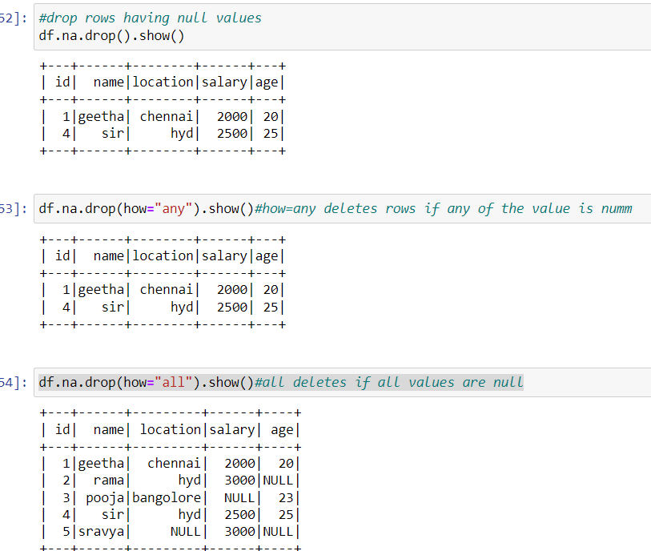

Filling missing values:

Groupby:

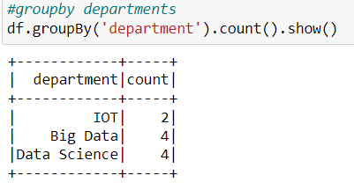

Program:

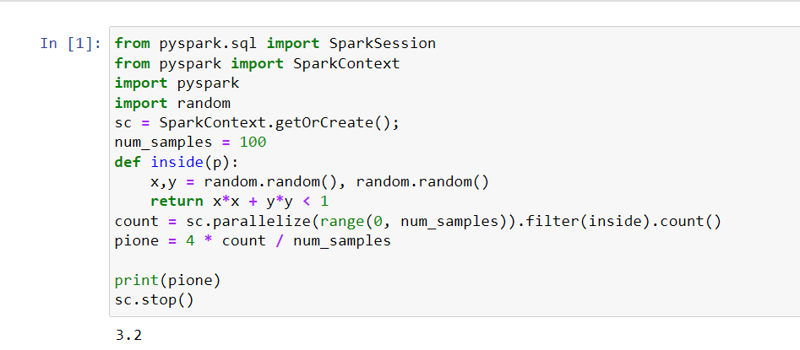

ETL :

ETL is procedure of migrating data from one system to another.

Extraction:is process of retrieving data out of homogenous or heterogenous sources.

Transformation:during data processing data is being cleaned and incorrect or inaccurate records are being modified or deleted.

Load:finally , the processed data is loaded into target systems.

Orders dataset:

Final dataset:

